VOIP lab experiment#13
Creating a queue group in the PBX

Installation and Repair of Telecommunications Equipment

Name of student:________________
Group Number:_________________
Date:_________________________

The purpose of the lab is to create a queue group for the company in the PBX. A queue group is when a group of people from the same department which the phone will ring following a queue.
- Enter a queue number
2-Enter a queue name (the department)
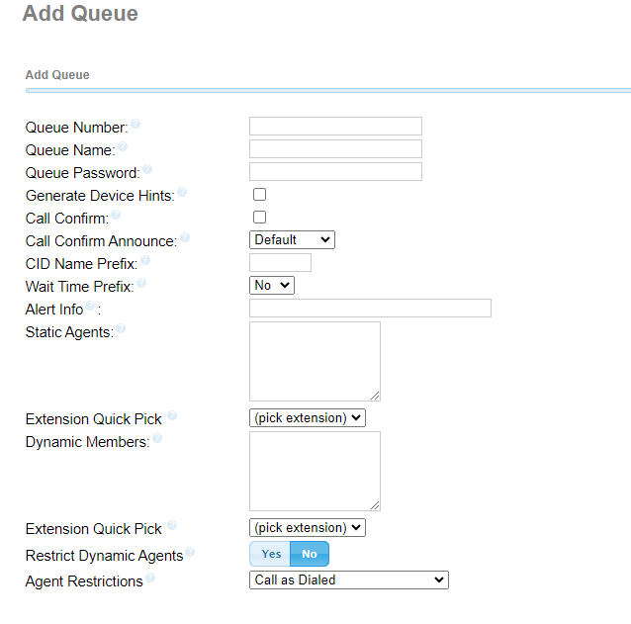

- In the extension quick pick, choose all the extension that belongs to this queue.

- In static agents chose the order of the queue. xxx.1 or xxx.2 and then xxx.3

- In the fail over destination, choose an extension and choose any extension

- Click on save and then apply config

